CODEBOOK (version 7.7)

**Content**

1. CODING STEP: CHARACTERISTICS OF THE ARTICLE 1

1.1 COUNTRY [COUNTRY] 1

1.2 MEDIA TYPE [MEDIATYPE] 1

1.3 DATE [DATE] 1

1.4 MEDIA OUTLET [MEDIA_OUTLET] 1

1.5 ARTICLE TITLE [ARTICLE_TITLE] 2

1.6 SECTION/CATEGORY [SECTION] 2

1.7 LENGTH [LENGTH] 2

1.8 FORM OF PRESENTATION [FORM_OF_PRESENTATION] 3

1.9 OTHER FORM OF PRESENTATION [FORM_OF_PRESENTATION_OPEN] 4

1.10 STARTING PAGE [STARTING_PAGE] 4

1.11 TONE OF THE ARTICLE (adapted from (Berry & Sobieraj, 2014)) [TONE] 4

2. CODING STEP: CREATION OF THE ACTOR LIST [ACTOR_NAME] 5

3. CODING STEP: ACTOR CHARACTERISTICS 8

3.1. ACTOR: ROLE/INSTITUTIONAL AFFILIATION GENERAL [ACT_ROLE_GENERAL] 8

3.2. ACTOR: ROLE/INSTITUTIONAL AFFILIATION POLITICAL COUNTRY [ACT_ROLE_POL_COUNTRY] 10

3.3. ACTOR: ROLE/INSTITUTIONAL AFFILIATION POLITICAL LEVEL [ACT_ROLE_ POL_LEVEL] 11

3.4. ACTOR: ROLE/INSTITUTIONAL AFFILIATIONPOLITICAL DOMESTICNATIONAL [ACT_ROLE_POL_DOMESTIC_NATIONAL] 11

3.5. ACTOR: ROLE/INSTITUTIONAL AFFILIATIONPOLITICAL FOREIGNNATIONAL [ACT_ROLE_POL_FOREIGN_NATIONAL] 15

3.6. ACTOR: PARTY AFFILIATION [ACT_PARTY_AFFILIATION] 15

3.7. ACTOR: PARTY AFFILIATION OTHER [ACT_PARTY_AFFILIATION_OPEN] 17

3.8. ACTOR: ORIGIN [ACT_ORIGIN] 17

3.9. ACTOR: ORIGIN OTHER [ACT_ORIGIN_OPEN] 18

3.10. ACTOR: GENDER [ACT_GENDER] 18

3.11. ACTOR: RELIGIOUS AFFILIATION [ACT_RELIGIOUS_AFFILIATION] 19

3.12. ACTOR: RELIGIOUS AFFILIATION OTHER [ACT_RELIGION_OPEN] 20

4. CODING STEP: ACTOR REFERENCES 21

4.1. ACTORS REFERENCES: REFERENCE OBJECT ACTOR [ACTREF_REFOBJ_ACTOR_ID] 21

4.2. ACTOR REFERENCES: REFERENCE ACTOR OTHER [ACTREF_REF_ACTOR_TEXT] 22

4.3. ACTOR REFERENCES: REFERENCE ORIGINATOR ACTOR [ACTREF_REFORIG_ACTOR] 22

4.4. ACTOR REFERENCES: GENUINE CONSTRUCTED RESPONSIVESNESS ACTOR [ACTREF_GENUINE_CONSTRUCTED_RESP_ACTOR] 23

4.5. ACTOR REFERENCES: VALENCE ACTOR [ACTREF_VALENCE_ACTOR] 24

4.6. ACTOR REFERENCES: RECOGNITION ACTOR [ACTREF_RECOGNITION_ACTOR] 25

4.7. ACTOR REFERENCES: RECOGNITION ACTOR OTHER [ACTREF_RECOGNITION_TEXT] 25

4.8. ACTOR REFERENCES: OUTRAGE ACTOR [ACTREF_OUTRAGE_ACTOR] 26

4.9. ACTOR REFERENCES: OUTRAGE ACTOR OTHER [ACTREF_OUTRAGE_TEXT] 27

5 CODING STEP: COMPLETION/FINALISATION 28

5.1 NOTES [NOTES] 28

***General preliminary notes:***  *perform the following steps for each news item to be coded. Observing the sequence of steps described in this codebook will facilitate coding.*

*Open codes should be made primarily in English. If this is not possible, code in German.*

# CODING STEP: CHARACTERISTICS OF THE ARTICLE

## COUNTRY [COUNTRY]

Code the country in which the article was published.

a Australia

c Switzerland

d Germany

l Lebanon

t Turkey

u USA

## MEDIA TYPE [MEDIATYPE]

Code whether the article was published in a newspaper, on a news website, or in a political blog.

n Daily newspaper

w News website

b Political blog

## DATE [DATE]

Enter the publication date of the article in the following format:

*YY-MM-DD*

***Example:*** *15-10-03🡪 article published on October 3rd, 2015*

## MEDIA OUTLET [MEDIA_OUTLET]

From the displayed list, select the title of the medium in which the article was published.

## ARTICLE TITLE [ARTICLE_TITLE]

Enter the full main title and subtitle of the article, separated by a slash (/), in the provided text box.

If you code an article in txt format, simply mark the title, copy it to the text box by clicking on ‘Get selection’, and then modify it manually (where applicable).

## SECTION/CATEGORY [SECTION]

Code the section/category within the medium, in which the article appeared.

1 **Politics** – this includes articles published in the section/category domestic/national affairs, foreign affairs/world and politics.

2 **Economy** – this includes articles published in the section/category economy, finance, business or similar.

3 **Culture/society** – this includes articles published in the section/category culture, lifestyle, society, media, arts or similar.

4 **Local/regional** – this includes articles published in an unspecified section dealing with local or regional affairs/events (with varying section/category titles, e.g. ‘Local/community’, ‘Regional’, ‘City post’, ‘Around …’, or simply naming the corresponding region/city).   
Caution: articles from the category ‘Local/regional’ that deal with political, economic or cultural topics should still be coded as ‘Local/regional’.

5 **Other** – to be applied only if the article cannot be assigned to one of the preceding sections/categories.

6 **No section/category** – to be applied only if the respective medium does not have a clear structure of sections/categories.

**Note 1**: blogs usually do not have a structure of sections or categories but consist of a single-page stream of posts, which are tagged specifically. Tags alone do not count as a section/category. In this case, code ‘6 No section/category’. However, sometimes the navigation bar on the upper or left margin of the website may be indicative of a section/category structure.

**Note 2**: to identify the section/category, use all the metadata displayed to you for the article to be coded (for example, section/category titles are often found in theURLs).

## LENGTH [LENGTH]

Count the article’s number of words, *excluding* the main headline, title, subtitle, and teaser. Readers’ comments and subheadings in the main text of the article are not counted.  
If you code an article in **txt format**, Angrist automatically enters the number of words in the text box.

If the article is **not** in **txt format**, estimate the number of words by counting the words in the first five lines of the article’s second paragraph, calculate the arithmetic mean of words per line and multiply it by the total number of lines in the article. In case of a fraction, round it up to the nearest integer (i.e. round 311.5 to 312).

**Note 1:** if the second paragraph comprises less than five lines, count the words in the first five lines of the third paragraph. If the article doesn’t contain a third paragraph, proceed as indicated in note 2.

**Note 2**: if the article consists of only one paragraph, count the words from the second up to - and including - the sixth line of the paragraph and then proceed as indicated in the coding instruction above.

**Note 3**: if the fifth line of the second paragraph ends with the first part of a hyphenated word, include this word in your count. Each number is counted as a word. Additional characters such as currency symbols are not counted (for example, ‘€ 500’ corresponds to 1 word). Words containing apostrophes are counted as one word (for example,‘it’s raining’ corresponds to 2 words), as are hyphenated words (for example, ‘50-year history’ corresponds to 2 words).

## FORM OF PRESENTATION [FORM_OF_PRESENTATION]

Code the (journalistic) genre of the article.

1. **News report**– (news) reports are fact-based coverage. They give an objective account of current events and differ considerably in content from opinions, analyses, and literary texts. They do not contain any personal assessments of the author.
2. **Opinion/comment** – opinion articles and comments are primarily interpretations, assessments and opinions of the author on a specific subject and are usually followed by the author’s name. This category also includes glosses, columns, and editorials. Editorials often appear on the front page and are meant to reflect the author's opinion on a topic. Glosses are brief opinion articles which typically employ a pointed argument and a polemic, funny, satirical, or biting rhetoric. They often appear as columns, i.e. in regular intervals and in a dedicated place in the newspaper (example: the *Streiflicht* on the front page of the *Süddeutsche Zeitung*).
3. **Analysis** – analyses are meant to provide the reader with more background knowledge about a topic or a group of topics. Current daily events may serve as an occasion for analyses.  
   Analyses examine topics systematically in order to identify and study the causes, characteristics and consequences of a situation/a condition/an issue. Causal analyses include, for example, historical observations of current events.
4. **Report** – reports describe the journalist’s personal experiences in an atmospheric way and also render feelings and impressions. Sometimes, the reported subject/main actors may play a more central role than the journalist.
5. **Interview/discussion** – interviews and discussions are written renditions of discussions or other exchanges between two or more persons. They are characterized by a clear change of the speaker.
6. **Critique/review** – critiques and reviews discuss current events and products in the field of culture (books, movies, events, etc.) and reflect the author's personal assessments (example: the discussion of a newly published political book is a critique/review. However, scientific studies are not cultural products in our sense; the presentation or discussion of them does not constitute a critique/review, but a report, analysis, or comment).
7. **Reprint** – reprints are excerpts from an (often not yet published) book or other media publications, which are not incorporated in an independent journalistic text.
8. **Letter to the editor** – letters are contributions published by non-journalistic writers on their own initiative that usually (but not always) refer back to previously published contributions.
9. **Other**

-99 **Not specified**

**Note:** in **Appendix 1** you will find several illustrative examples of the different (journalistic) forms of presentation as an aid to your decision.

## OTHER FORM OF PRESENTATION [FORM_OF_PRESENTATION_OPEN]

***Preliminary note:*** *code this variable only if you coded the previous variable ‘Form of presentation’ (1.8) with ‘Other’.*

In the open text box, enter the article’s journalistic genre.

## STARTING PAGE [STARTING_PAGE]

***Preliminary note:*** *code this variable only for daily newspapers!*

nn Code the number of the page on which the article begins.

*Example: an article begins on the third page of a newspaper, hence the page code for this article is ‘03’.*

## TONE OF THE ARTICLE (adapted from (Berry & Sobieraj, 2014)) [TONE]

How venomous is this? This variable asks your assessment of the overall tone of the article. This particular variable is about the intensity of the outrage.

**Note 1**: The term outrage refers to a particular form of political discourse involving the mindful attempt to provoke an emotional response from the audience, usually in the form of anger, fear, or moral righteousness. Outrage is often, but not always, accomplished through the use of categorical statements, exaggerations, and partial truths about opponents which may take the form of individuals, organizations, or entire communities of interest (e.g., progressives or conservatives) or circumstance (e.g., immigrants). Outrage sidesteps the messy nuances of complex political issues in favor of ad hominem attacks, overgeneralizations, mockery, and dire forecasts of impending doom.

**Note 2**: code the overall impression conveyed by the article, not just by parts of the article or single communicative acts reported in the article.

0 Overall tone is more aptly described as **conventional political speech**: Content and form OVERALL are more aptly described as “conventional” political speech, even if there are moments that technically count as outrage.

1 **Light** intensity outrage: Close to the border of “conventional” political speech.

2 **Moderate** intensity outrage: Outrage is present, but not overly emotional in form and/or content.

3 **Intense** outrage: There are windows of reason, but the content and/or form is generally quite emotional.

4 **Very intense** outrage: Content and/or form may match, but infrequently exceeds this level of emotionality.

# CODING STEP: CREATION OF THE ACTOR LIST [ACTOR_NAME]

***Preliminary note****: in this step, create a separate list of all actors* ***mentioned*** *in the text for each article you are coding. The order of the actors’ occurrence in the* ***main text of the article*** *defines their order of listing.*

An actor is understood here as an at least potentially acting subject who is able to at least potentially participate actively in a discourse and must be identifiable as such in the text. Actors can be individuals (e.g. Angela Merkel) or collective actors (e.g. the Federal Government).

If both a **collective actor** (e.g. an institution or organization) and an individual **representative or speaker of this collective actor** are mentioned in an article, they are listed separately.

Note that incidentally mentioned individual or collective actors are also included. A **single, incidental mention of an actor, also in the form of background information or personal characteristics, is sufficient to code them.**

The aim of this coding step is to capture **all mentioned potential discourse participants**.

**Note:** there are two key criteria with corresponding key questions for the creation of the actor list:

1. **Identifiability**: is there any information in the text that allows for **finding out more information about the potential actor** or can this information be obtained with the help of an online search engine in 5 minutes or less?
   * An actor must be an **identifiable,** acting subject. For example, ‘many’ or ‘others’ do not count as actors, because they are not identifiable. An actor is considered as identifiable if the information provided about the actor allows the reader to find out more information about them (either in the present text but also beyond, by means of a simple search, e.g. with an online search engine).
2. **Potential discourse participation:** could the potential actor **at least potentially participate in a discourse**?
   * An actor must be a **potential participant in the discourse**. An identifiable individual or collective actor must be able to potentially participate *as such* in the discussion on the article’s topic. This also means that non-organized groups of individuals and collectives (such as ‘Christians’, ‘Muslims’, ‘German farmers’) are not coded as actors, because they are unable to participate *as such* in the public debate. Organized actors, groups and collectives (such as ‘the church’ as an institution, not as a place, the ‘Central Council of Muslims in Germany’, ‘farmers' associations’), however, are coded as actors because they are able to participate *as such* in the public discourse.

**Coding instruction:**

Txt files: if you code an article in txt format, mark each actor appearing in the text and subsequently click on the yellow button labelled ‘Actor’.

PDF files: if you code an article in PDF format, print it and mark each actor mentioned with a yellow highlighter. In a consensus discussion with a second coder, actors appearing several times are summarized and the final list is created. This list is saved in Excel format. The description of each actor on the final list is entered manually in Angrist for further actor coding.

**Caution:** for individual actors, the description will usually be equivalent to the name of the respective actor; functional descriptions or affiliations to organizations should be added only if the actor's name would otherwise be ambiguous. For collective actors, the name of the actor is usually the name of the respective institution/organization.

Add an English translation of the actor description in the field ‘Description’. If you are not able to translate into English, enter a German description .

**Caution**: the author of the article is always the first actor to be coded. The author is not recorded by name but is referred to only as the ‘author of the article’. By default, Angrist suggests the author of the article as the first entry on the actor list (also without prior marking). If you code an article in txt format, you therefore do not need to mark the author.

**Treatment of borderline cases:**

* **Demonstrating and other protesting groups of persons** are coded as identifiable collective actors if they appear organized as such (e.g. evangelical Christians demonstrating against abortion laws).
* Actors who can act both as **geographical reference** or **source of information** and as **discourse participants**, such as **countries**, **cities**, **churches or the media**, are coded as actors only if it is **clear from the context of the reference** that they act as **independent potential participants in the discourse**. They are not coded if, in the context of their mention, they only point to a place.
* **‘The state’** should be interpreted as equivalent to the current government of the respective country and therefore included as collective actor in the actor list (caution: this also includes mentions of countries as states (e.g. ‘Israel announced XY’) but not mentions of countries without a clearly identifiable reference to the state.
* **Fictitious actors** (e.g. characters from film and literature) are not coded.
* **Deceased actors, i.e. also historical actors (for example, Muhammed, Jesus, Maria)** are not coded.
* **Anonymously cited actors** (e.g. actors whose name was changed by the journalist for their protection or who are not named at all and cannot be identified by other means) are not coded as actors.

***Example 1****: ‘The head of the British government today commented on the recent events in London.’ 🡪 The actor is identifiable because he/she also represents an actual discourse participant (see (b)) on whom additional information can be sought and found based on the information given in the article (‘The head of the British government’; see (a)).*

***Example 2****: ‘The federal government’, ‘The Greens’, ‘The opposition’ or ‘The army’ each are collective actors and are therefore coded as actors.*

**In case of doubt**: shouldn’t it be clear from the context of the article whether the criteria for the identification of actors are met (identifiability and potential discourse participation), code conservatively, i.e. do not include them in the actor list.

***Example 3****: ‘Last week, after Republican governors in South Carolina and Alabama had pressed for the removal of the Confederate battle flag at their capitals, Southern Republicans in the House moved to preserve the right to lay those flags on Confederate graves at federal cemeteries, prompting an uproar led by African-American House members.’🡪 ‘Republican governors in South Carolina and Alabama’ are two identifiable individual actors. However: it is not clear from the context of the article whether 'Southern Republicans in the House‘ and 'African-American House members‘ refer to groups as a whole (and therefore are coded as actors) or if these designations are used as characterizations of several individual persons, who would then be not further identifiable. Therefore, they both should not be coded as actors.*

# CODING STEP: ACTOR CHARACTERISTICS

***Preliminary note:*** *in turn code the characteristics of all actors in the article listed in coding step 2. Decisive for coding is the status at the time of the first publication of the respective article (i.e. basically the investigation period 1.8.2015 to 31.7.2016).*

## ACTOR: ROLE/INSTITUTIONAL AFFILIATION GENERAL [ACT_ROLE_GENERAL]

In this step you will code the actor’s role or institutional affiliation. For this purpose, consider all the contextual information contained in the text, **omitting your own knowledge.**Only code the actor’s **main role**, which is determined by   
(a) explicit reference to the actor (made by the journalist/blogger) or   
(b) the entire context of the article (e.g. based on the topic of the article).

If you are unsure about the role of an actor, do a quick online search to obtain the necessary information for correct coding (up to 5 minutes).

1 **Political actor**

2 **Military/police/state militia**

3 **Legal representatives** (national and supra-national, e.g. prosecutors, courts, state judges, spokespersons of the courts; excluding the police [see 2] and lawyers [see 19])

4 **Other national representatives** (administration, national supervisory authorities, civil protection, national intelligence services, fire brigade, emergency service, etc.; excluding military/police [see 2]; officials only if they appear in the role of officials)

5 **Entrepreneurs and business representatives** (e.g. security traders, professional farmers, business associations such as BDI and Chambers of Commerce and Industry, individual companies)

6 **Representatives of permanently organized civil society associations and general associations** (e.g. Child Protection Agency, Joint Welfare Association), trade unions (e.g. ver.di), NGOs (e.g. BUND, Greenpeace); associations, trade unions and NGOs in the form of collectively organized actors; interest groups or other associations (e.g. pupil’s council, Pegida)

**Note 1**: civic associations, associations, and NGOs with a religious background are not coded with 6 (see 15). A civil society organization is considered permanent if it has been established not only to enforce a precise and clearly defined policy objective.

***Example****: the Swiss minaret initiative, which had the specific goal of enforcing a referendum on the approval of minarets in Switzerland, is not a permanent civil society association.*

**Note 2**: ordinary parties are part of the political institutional system and therefore never coded as civil society actors (Code 6).

7 **Journalists** (television, radio or press journalists, news agencies, etc.)

**Note 1**: journalistic actors must work at least part-time as such; for **authors of guest contributions** who are representatives of another group of actors, the latter should be coded. For this purpose, consult all contextual information available, for example info boxes. If, despite the info box, you are not sure which role the guest author should be assigned to, carry out a quick online search. This means that you should only code actors as journalists who, based on the information available to the reader, are likely to cover a major part of their living expenses through their journalistic work.

**Note 2**: see below for double roles as journalist and blogger (note 3a).

8 **Bloggers**

**Note**: see below for double roles as journalist and blogger (note 3a).

9 **Scientists/intellectuals/representatives of the Arts and (academically oriented) high culture** (e.g. researchers, philosophers, authors of books, representatives of think tanks, e.g. Stiftung Wissenschaft & Politik, American Enterprise Institute for Public Policy Research etc.)

10 **Representatives of (non-academically oriented) popular culture and entertainment** (e.g. TV stars, musicians, actors, entertainers, authors of popular literature, etc.)

13 **Representatives of sports** (e.g. football players, trainers, representatives of a team, etc.)

14 **Representatives of churches, religious or faith communities** (e.g. the Pope, spokesperson of a church, priests, imams etc.)

**Note**: select code 14 only for clergymen/-women or representatives of an organization/institution headed by religious dignitaries, not for secular organizations of one or more religious communities (see code 15).

15 **Representatives of religious associations** (e.g. Central Council of Jews in Germany, Turkish-Islamic Union of the Institute for Religion (DİTİB), Islamic Council for the Federal Republic of Germany, Council of Religions, International Council of Christians and Jews, World Parliament of Religions)

**Note**: select code 15 only for secular organizations of one or more religious communities but not for clergymen/-women or representatives of an organization/institution headed by religious dignitaries.

16 **Ordinary citizens not engaged in collectively organized protest** (e.g. questioned passers-by, individuals affected by political and social processes speaking for themselves, self-help organizations provided they do not participate actively in politically organized protest, but not defendants in court cases [see code 19]).

17 **Ordinary citizens engaged in short-term, collectively organized protest** (e.g. questioned demonstrators; individuals speaking of themselves as affected by political and social processes (e.g. Swiss minaret initiative), self-help organizations, if they are directly involved in organized political protest; self-help organizations, provided they participate actively in politically organized protest)

18 **Assassins, terrorists** (in the sense of actors who have committed, are suspected to have committed, or are planning to commit violent crimes)

19 **Others** (e.g. accused persons and lawyers, school principals, non-governmental paramilitary groups such as vigilant groups, practicing doctors, etc.)

**Note**: select the category ‘Others’ only in cases in which the actor cannot be clearly assigned to any role.

**Example**: *the organization Hezbollah—which can appear as a political party (code 1), as a terrorist organization (code 18), and as a paramilitary militia (code 19 - Others)—should be coded rather as a party (code 1) or as a terrorist organization (code 18), depending on how it is actually portrayed in the article; it should be coded as a paramilitary militia (code 19)only if it is specifically described neither as a party nor as a terrorist organization.*

-99 **Not specified**

**Note 1:** the role/institutional affiliation should not only be coded for representatives of institutions or organizations, but also for institutions/organizations themselves! This means, for example, that this variable should not only be coded for **representatives** of courts, media outlets, universities, associations and churches, but also for **courts, media outlets, universities, associations and churches** as collective actors themselves.

**Note 2**: if the text assigns several roles/institutional affiliations to one actor, code the role/institutional affiliation mentioned first in the main text of the article (i.e. not in the heading or title).

**Note 3a**: if the author of an article is both a journalist and a blogger, their function in the current article determines the coding decision. Code authors as bloggers if they are the authors of a blog, even if they also work as journalists in other contexts. However, code authors as journalists if they are the authors of a newspaper or news website article. Exception: the author is explicitly referred to as a blogger in the article, for example, in a brief author information at the end.  
 **Note 3b**: if the author of an article mentions actors who are both journalists and bloggers, the role assigned to the actor by the author determines the coding decision. If the author doesn’t assign them a clear role, select the category ‘Journalists’ (code 7).

**Note 3c:** if no author is specified in an article, the author should be assigned code 7 (‘Journalists') for daily newspapers and news websites, and code 8 (‘Bloggers’) for blog posts.

## ACTOR: ROLE/INSTITUTIONAL AFFILIATION POLITICAL COUNTRY [ACT_ROLE_POL_COUNTRY]

Is the actor a **national** or a **foreign** actor?

Code this variable analogously to point 5.8 ‘Origin’ and always take the country in which the media text appeared as a point of reference.

***Example****: a German actor appearing in an article from a Swiss daily newspaper is considered a foreign actor.*

11 **National actor**

12 **Foreign actor**

-99 **Not specified**

**Note**: the author of an article is coded as a national actor even if their origin is coded in the following with ‘-99 Not specified’. The only exceptions are foreign guest authors.

***Preliminary note****: the following variables up to and including point 5.5 are only coded for* ***political actors****.*

## ACTOR: ROLE/INSTITUTIONAL AFFILIATION POLITICAL LEVEL [ACT_ROLE_ POL_LEVEL]

Is the actor a national or sub-/supranational actor?

1 **National actor**

**Note**: parties acting at national level (for example, the SPD) should be coded as a national actor, unless explicit reference is made to a specific level of party organization (e.g. SPD local association, i.e. subnational level).

2 **Sub-/supranational actor** (e.g. regional politicians, state parliaments, state and non-state governors, simple local community members, representatives of the EU and the UN or their organizations)

-99 **Not specified**

***Preliminary note****: the following variable (5.4) is coded only for* ***domestic, national political actors****.*

## ACTOR: ROLE/INSTITUTIONAL AFFILIATIONPOLITICAL DOMESTICNATIONAL [ACT_ROLE_POL_DOMESTIC_NATIONAL]

If the political actor is a national domestic actor, code whether they belong to the **executive** or **legislative** in the **national** political system. Code only the actor’s **main role**, which is determined by (a) explicit reference to the actor (made by the journalist/blogger) or (b) the entire context of the article (e.g. based on the topic of the article).

Coding should be based solely **on the information contained in the article** (but not on, for example, prior knowledge or the presumed prior knowledge of a generally educated reader). Ask yourself: what information about the role/institutional affiliation of the actor can be found in the article?

This information may be more or less explicit or implicit in the article. If you are unsure about the meaning of a piece of information in an article (for example, an official title or abbreviation of an organization), do a quick online search (up to 5 minutes) to understand the information in the article correctly.

Always choose the most specific code concerning the information given in the article. For example, code 11110 should be used only if the executive is referred to generally as ‘The state’ or ‘The federal state’, or if country names are cited as representative of the state. For a more specific reference (e.g. ‘Angela Merkel’), the more specific code (e.g. 11111) should be assigned.

***Example****: in an article, a statement by ‘Angela Merkel, chairwoman of the Union’ is casually mentioned. If you do not know the abbreviation ‘Union’ or cannot clearly interpret it, do a brief internet research and accordingly code ‘11121 Legislative: representatives of the government party/parties or the government coalition as a whole’ (but not ‘11110 Executive as a whole’, since her function as Federal Chancellor is not mentioned in the article).*

1. **Executiveas a whole:** e.g. ‘The state’, ‘The federal government’(in Germany)
2. **Executive: head of government**

* AUS – Tony Abbott (until 15 Sept 2015)/Malcolm Turnbull (Prime Minister)
* GER – Angela Merkel (Federal Chancellor)
* LEB – Tammam Salam (premier, Prime Minister)
* SUI – Federal Council: Didier Burkhalter, Johann Schneider-Ammann, Eveline Widmer-Schlumpf, Doris Leuthard, Ueli Maurer, Simonetta Sommaruga (Federal President), Alain Berset, Corina Casanova (Federal Chancellor)
* TUR – Ahmet Davutoğlu (Prime Minister)
* USA – Barack Obama (President)

1. **Executive: head of state**

* AUS – Queen Elizabeth II (Queen)
* GER – Joachim Gauck (Federal President)
* [LEB – not existing in person; therefore, this code should not be used for libanese actors]
* SUI – Simonetta Sommaruga (Federal President)
* TUR – Recep Tayyip Erdoğan (President of the State)
* USA – Barack Obama (President)

1. **Executive: other government representatives at national level** (e.g. ministers and ministries but also spokespersons of the ministers and heads of state)
2. **Legislative as a whole**: e.g. ‘German Bundestag’, ‘the Parliament’,‘Congress’, ‘Senate’, ‘House’
3. **Legislative: representatives of the government party/parties or the government coalition as a whole**

* AUS – The Liberal Party of Australia (The Liberals, Lib, Libs, LPA)
* AUS – The National Party of Australia (The Nationals, The Nats, NPA)
* GER – Christlich Demokratische Union Deutschlands (CDU) [Christian Democratic Union of Germany]
* GER – Christlich-Soziale Union in Bayern (CSU) ) [Christian Social Union of Germany]
* GER – Sozialdemokratische Partei Deutschlands (SPD) [Social Democratic Party of Germany]
* LEB – Courant du Futur – ‏تيارالمستقبل – Tayyār al-Mustaqbal [Future Movement]
* LEB – Parti socialiste progressiste (PSP) –‏الحزبالتقدميالاشتراكي‎ –Al-Hizb at-taqadummi al-ischtiraki [Progressive Socialist Party]
* LEB - Phalanges libanaises (Kataëb) – الكتائباللبنانية– Hizb al-Kata'ib al-Lubnaniya, [Phalange, Kata’ib-Partei, Kataeb Party, Lebanese Phalanges Party]
* LEB – Parti national liberal (PNL) – حزبالوطنيينالأحرار– Hizb el-wataniyin el-ahrar (Al-Ahrar) [National Liberal Party, NLP]
* LEB - Mouvement du renouveau démocratique – ‏حركةالتجددالديموقراطي‎ – Ḥarakat at-taǧaddud ad-dīmuqrāṭī [Democratic Renewal]
* LEB – Mouvement de la gauche démocratique au Liban (MDG) – ‏حركةاليسارالديمقراطي‎ – Ḥarakat al-Yasār ad-Dīmuqrāṭī (HYD) [Democratic Left Movement]
* LEB – Mouvement des dépossédés, Mouvement Amal (Amal) – ‏حركةأمل – Harakat amal [Amal Movement, Hope Movement]
* LEB – Hezbollah, ‘Parti de Dieu’ –حزبالله‬ – Ḥizbu 'llāh [Hezbollah] ‬‬‬‬‬
* LEB – Parti social nationaliste syrien (PSNS) – الحزبالسوريالقوميالاجتماعي – al-Ḥizb as-Sūrī al-Qaumī al-Iǧtimāʿī [Syrian Social Nationalist Party, SSNP]
* LEB – Courant patriotique libre (CPL) – التيارالوطنيالحر – al-Tayyār al-waṭanī al-ḥurr [Free Patriotic Movement]
* SUI – Fraktion der Schweizerischen Volkspartei der Bundesversammlung (V) - Groupe de l'Union démocratique du centre l'Assemblée fédérale [Swiss People's Party /Democratic Union of the Federal Assembly]
* SUI – Sozialdemokratische Fraktion der Bundesversammlung (S) – Groupe socialiste de l'Assemblée fédérale [Socialist Union of the Federal Assembly]
* SUI –CVP/EVP Fraktion der Bundesversammlung (CE) (CVP = Christlichdemokratischen Volkspartei, EVP =Evangelischen Volkspartei)– Groupe PDC/PEV l'Assemblée fédérale (PDC = Le Parti démocrate-chrétien, PEV =Le Parti évangélique suisse) [Christian Democratic People's Party],
* SUI – FDP-Liberale Fraktion der Bundesversammlung – Groupe libéral-radical (RL) [Liberal Union of the Federal Assembly]
* SUI – Grüne Fraktion der Bundesversammlung (G) – Groupe des Verts de l’Assemblée fédérale [Green Union of the Federal Assembly]
* SUI – Grünliberale Fraktion der Bundesversammlung (GL) – Groupe vert-libéral l'Assemblée fédérale [Green Liberal Union of the Federal Assembly]
* SUI – Fraktion der Bürgerlich-Demokratischen Partei der Bundesversammlung (BD) – Groupe du parti bourgeois démocratique de l'Assemblée fédérale [Bourgeois Democratic Union of the Federal Assembly]
* TUR – Adalet ve Kalkınma Partisi (AKP) [Justice and Development Party]
* USA – Democratic Party (Democrats)

1. **Legislative: representatives of the opposition party/parties or the opposition as a whole**

* AUS – Australian Labor Party (ALP)
* GER – Die Linke [The Left]
* GER – Bündnis 90/Die Grünen [Alliance '90/The Greens]
* LEB – Forces Libanaises (FL) – القواتاللبنانية – al-Quwwāt al-lubnāniyya [Lebanese Forces]
* SUI – [Special case: no opposition in national parliament]
* TUR – Cumhuriyet Halk Partisi (CHP) [Republican People’s Party]
* TUR – Milliyetçi Hareket Partisi (MHP) [Nationalist Movement Party]
* TUR – Halkların Demokratik Partisi (HDP) [Peoples' Democratic Party]
* USA – Republican Party, Republicans, Grand Old Party (GOP)

1. **Legislative: other legislative representatives at national level** (e.g. so-called crossbenchers such as the‘One Nation Party’ in Australia, the German South Eastern European Parliamentary Group, the Parliamentary Circle of Friends Berlin-Taipei, supra-factional discussion groups such as ‘Denkwerk Demokratie’, the so-called pizza connection)

-99 **Not specified**

**Special rule 1**: for the USA and Switzerland, the actors corresponding to categories 11111 and 11112 are identical (SUI: Simonetta Sommaruga; USA: Barack Obama). To unambiguously define the coding category to be applied, consider the **context** in which the actor appears: if they appear in the context of national politics, code ‘11111 – Executive: head of government’, if they appear in the context of international politics, code ‘11112 – Executive: head of state’.

**Special rule2**: **spokespersons** of the head of government or head of state are coded as ‘11113 – Executive: Other government representatives at national level’ or foreign representatives of the executive.

Code **spokespersons** as the actors they speak for:

***Example 1****: spokespersons of Angela Merkel are coded as ‘*11113 - *Executive: other government representatives at national level’ (caution: of course, this applies only to German articles! In all other cases, code as foreign representatives of the government).*

***Example 2****: spokespersons of the White House are coded as national, foreign actors of the executive (caution: this only applies to non-American articles! For American articles, please choose ‘Executive: other government representatives at national level’).*

**Note**: the **executive** refers to the executive power of a country and includes the government, i.e. head of government, head of state, minister, and also spokespersons of the government at **national** level. The **legislative**, on the other hand, refers to the legislative authority and is responsible for the consultation and adoption of laws as well as for the supervision of the executive. The **legislative** comprises party fractions represented in the **national** parliaments (government parties or opposition parties) and its members as well as party organizations at **national** policy level (for example, the SPD executive committee).

**Special rule 3**: for candidates for an office (e.g. presidential candidate or candidate for chancellor), code the office which the candidate held when the article was published. If the candidate has no political office, as in the case of D. Trump, then they should be coded as follows:

Role GENERAL: **1 Political actor**

Role POL_COUNTRY: **11 Domestic actor**

Role POL_LEVEL: **1** **National actor**

Role POL_DOMESTIC_NATIONAL: **-99 Not specified**

***Preliminary note****: the following variable (5.5) is coded only for* ***foreign, national political actors****.*

## ACTOR: ROLE/INSTITUTIONAL AFFILIATIONPOLITICAL FOREIGNNATIONAL [ACT_ROLE_POL_FOREIGN_NATIONAL]

If the actor is a foreign national political actor, code whether they belong to the **executive** or the **legislative** branch.

1. **Executive – representatives of the government** (no distinction between head of government, head of state, ministers and spokespersons)
2. **Legislative – representatives of the legislative** (no distinction between opposition and governing parties, all foreign politicians at national level)

-99 **Not specified**

**Note**: foreign states that are not described in detail but act as actors as such are usually coded as executive. If they are referred to in the context of the article as legislators, they are coded as a legislative.

***Preliminary note****: the following variable (5.6) is only coded for* ***domestic actors****.*

## ACTOR: PARTY AFFILIATION [ACT_PARTY_AFFILIATION]

Code the party affiliation of the mentioned actor, provided it is clearly specified in the article. In order to define party affiliation, use the contextual information provided in the article, omitting your own knowledge.

This means that you should identify organizations and abbreviations of organizations explicitly named in the article through an online search but not code party affiliation if no party organization is mentioned in the article or if party affiliation remains implicit.

The party affiliation of actors is coded only if the context clearly indicates party membership.

If an actor’s party affiliation is not indicated or if the actor is a collective domestic actor with unclear political affiliation, e.g. the federal government, code ‘-99 Not specified’. For parties and their sub-organizations as collective actors, the party affiliation should be coded (for example, ‘Jusos’ as the youth wing of the SPD are coded as ‘SPD’).

1. GER – Christlich Demokratische Union Deutschlands/Christlich-Soziale Union in Bayern (CDU/CSU) [Christian Democratic Union of Germany/Christian Social Union of Germany]
2. GER – Sozialdemokratische Partei Deutschlands (SPD) [Social Democratic Party of Germany]
3. GER – Die Linke [The Left]
4. GER – Bündnis 90/Die Grünen [Alliance '90/The Greens]
5. GER – Alternative für Deutschland (AfD) [Alternative for Germany]
6. GER – Freie Demokratische Partei, Freie Demokraten (FDP) [Free Democratic Party, Free Democrats, former: The Liberals]
7. GER – Other (record manually)
8. SUI – Bürgerlich-Demokratische Partei (BDP) - Parti bourgeois démocratique (PBD) [Conservative Democratic Party of Switzerland]
9. SUI – Christlichdemokratische Volkspartei (CVP) - Parti démocrate-chrétien (PDC) [Christian Democratic People's Party of Switzerland]
10. SUI – Christlichsoziale Partei, Mitte Links (CSP) – Parti chrétien-social, Centre gauche (PCS) [Christian Social Party (CSP)]
11. SUI – Evangelische Volkspartei (EVP) - Parti Evangelique Suisse (PEV) [Evangelical People's Party of Switzerland]
12. SUI – FDP.Die Liberalen (FDP) - PLR. Les Libéraux-Radicaux [The Liberals]
13. SUI – Grüne Partei der Schweiz (GPS) - Parti écologiste suisse (PES) [Green Party of Switzerland]
14. SUI – Grünliberale Partei (GLP) - Parti vert’libéral Suisse (PVL) [Green Liberal Party of Switzerland]
15. SUI – Lega dei Ticinesi (Lega) - Ligue des Tessinois [Ticino League]
16. SUI – Mouvement citoyens romands/genevois (MCR/MCG) [Geneva Citizens' Movement]
17. SUI – Schweizerische Volkspartei (SVP) - Union démocratique du centre (UDC) [Swiss People's Party]
18. SUI – Sozialdemokratische Partei der Schweiz (SP) - Parti socialiste suisse (SPS) [Social Democratic Party of Switzerland]
19. SUI – Other (record manually)
20. USA – Democratic Party (Democrats)
21. USA – Republican Party, Republicans, Grand Old Party (GOP)
22. USA – Other (record manually)
23. AUS – The Liberal Party of Australia (The Liberals, Lib, Libs, LPA)
24. AUS – Australian Labor Party (ALP)
25. AUS – The National Party of Australia (The Nationals, The Nats, NPA)
26. AUS – Australian Greens (The Greens)
27. AUS – Other (record manually)
28. LEB – Courant du Futur – ‏تيارالمستقبل – Tayyār al-Mustaqbal [Future Movement]
29. LEB – Parti socialiste progressiste (PSP) – ‏الحزبالتقدميالاشتراكي‎ – Al-Hizb at-taqadummi al-ischtiraki [Progressive-socialist Party]
30. LEB – Forces Libanaises (FL) – القواتاللبنانية – al-Quwwāt al-lubnāniyya [Lebanese Forces (LF)]
31. LEB – Phalanges libanaises (Kataëb) – الكتائباللبنانية – Hizb al-Kata'ib al-Lubnaniya, [Phalange, Kata’ib-Partei, Kataeb Party, Lebanese Phalanges Party]
32. LEB – Parti national liberal (PNL) – حزبالوطنيينالأحرار – Hizb el-wataniyin el-ahrar (Al-Ahrar) [National Liberal Party(NLP)]
33. LEB – Mouvement du renouveau démocratique – ‏حركةالتجددالديموقراطي‎ – Ḥarakat at-taǧaddud ad-dīmuqrāṭī [Democratic Renewal]
34. LEB – Mouvement de la gauche démocratique au Liban (MDG) – ‏حركةاليسارالديمقراطي‎ – Ḥarakat al-Yasār ad-Dīmuqrāṭī (HYD) [Democratic Left Movement (DLM)]
35. LEB – Mouvement des dépossédés, Mouvement Amal (Amal) – ‏حركةأمل – Harakat amal [Amal Movement, Hope Movement]
36. LEB – Hezbollah, ‘Parti de Dieu’ – حزبالله‬ – Ḥizbu 'llāh [Hezbollah]‬‬‬‬
37. LEB – Parti social nationaliste syrien (PSNS) – الحزبالسوريالقوميالاجتماعي – al-Ḥizb as-Sūrī al-Qaumī al-Iǧtimāʿī [Syrian Social Nationalist Party (SSNP)]
38. LEB – Courant patriotique libre (CPL) – التيارالوطنيالحر – al-Tayyār al-waṭanī al-ḥurr [Free Patriotic Movement (FPM)]
39. LEB – Other (record manually)
40. TUR – Adalet ve Kalkınma Partisi (AKP) [Justice and Development Party]
41. TUR – Cumhuriyet Halk Partisi (CHP) [Republican People's Party]
42. TUR – Milliyetçi Hareket Partisi (MHP) [Nationalist Movement Party/ Nationalist Action Party]
43. TUR – Halkların Demokratik Partisi (HDP) [Peoples' Democratic Party]
44. TUR – Other (record manually)
45. No party affiliation (only for explicit (self-) nominations and if none of the above-mentioned categories applies. Caution: do not code any personal judgements!)

-99 Not specified

**Special rule**: the only exception to this rule are heads of state and heads of government, whose party affiliation is coded **even if it is not specified** in the text.

## ACTOR: PARTY AFFILIATION OTHER [ACT_PARTY_AFFILIATION_OPEN]

***Preliminary note****: this variable is coded only if the previous variable ‘Party affiliation’ was coded with ‘Other’!*

Enter in the open text box which political party the actor belongs to.

## ACTOR: ORIGIN [ACT_ORIGIN]

Code the origin of the actor by selecting the name of the country from the list displayed in Angrist. For this purpose, consider all contextual information about the actor (e.g. descriptions by the author or other actors in the text) contained in the article, but not your own knowledge or external information (e.g. online search engines). In doing so, the **current main operational background** is crucial, i.e. the current place of residence and work, but not the ethnic origin. For exiles who talk about their country of origin, code the country of origin and not the country of exile.

**Note 1:** in borderline cases such as foreign correspondents, the coding decision may be facilitated by asking what operational activity the actor's employer pursues, how long the current operational activity will probably last, and in which role the actor appears in the article (e.g. native or foreign).

The origin of the reporting or citing journalists/bloggers is coded as ‘99 - Not specified’. Exception: foreign journalists and authors of guest contributions who act as commentators, if their origin is specified and/or can be deduced from contextual information.

If the actor’s country of origin is not included in the list of country codes (see Appendix 2: list of country codes), select ‘Other’ and enter the country of origin in the open category ‘Origin Other’ (5.9). If the country of origin is a state with limited recognition and at least partially overlaps with a recognized state (e.g. Kurdistan with Turkey, Syria, Iraq and Iran), select the country code of the recognized state and enter the name of the state with limited recognition in the field for open coding.

For actors from international (for example UN) and supranational (for example EU) organizations, also select ‘Other’ and enter the name of the organization in the open category ‘Origin Other’ (5.9). The same applies to transnational terrorist organizations such as IS or al Qaeda. It does not apply to terrorist organizations that operate exclusively within a country (for example the NSU); here, the country is coded, provided it is clear from the article’s context.

**Note 2**: code the origin of all representatives of the executive and legislative branches, **even if it is not specified**! If it is clear from the context, also code the origin of actors who were coded with ‘Other’ or ‘Not specified’ for the variable ‘Role/institutional affiliation’.

***Example 1****: ‘Chancellor Angela Merkel rated the government's measures to control the economic crisis as a good and important step towards overcoming the difficulties.’* C*ode ‘Germany’—it is clear from the contextual information that the speaker is the Chancellor, also if her country of origin is not explicitly named.*

***Example 2****: the attribution of the origin by other actors (e.g. the author) often takes place during role assignment and can also be implicit. For example, ‘IS fighter from Mosul’ is coded as ‘Iraq’ and ‘Münster’s theologians’ as ‘Germany’.*

## ACTOR: ORIGIN OTHER [ACT_ORIGIN_OPEN]

***Preliminary note****: this variable is coded only if the previous variable ‘Origin’ (5.8) was coded with ‘Other’.*

Enter the origin of the actor in the open text box.

## ACTOR: GENDER [ACT_GENDER]

Code the gender of the actor.

1 Female

2 Male

3 Other

-99 Not specified

**Note**: unless the actor’s gender is explicitly different from the biological sex, code on the basis of the recognizable biological sex (e.g. gender-typical names). Code ‘Other’ only if the text explicitly emphasizes a deviant gender identity (such as transgender) of the actor. Code ‘Not specified’ only if the gender of the actor cannot be inferred from the explicit information contained in the article. For collective actors, also code ‘-99 Not specified’.

## ACTOR: RELIGIOUS AFFILIATION [ACT_RELIGIOUS_AFFILIATION]

Code the religious affiliation of the actor, provided it can be clearly deduced from the article, **explicitly or implicitly**. Religious affiliation refers to the **actor’s individual profession of faith**. Important: only use contextual information from the article but not your own knowledge.

Religious affiliation in this sense cannot be deduced from being a member of a church or belonging to a religious organization or group alone (for example membership in political parties such as the CDU in Germany or Israeli citizenship).

The actor’s individual profession of faith can be deduced from membership in an organization only if it is a necessary condition for membership. This means, among other things, that members of religious fundamentalist organizations such as ISIS or al-Qaida should be coded as ‘Islamic’, since there is a necessary self-identification of the actor as Islamic.

**The highest state offices of Lebanon** are a special case: the president and the commander-in-chief of the armed forces are always coded as Maronite, the prime minister as Sunni, and the speaker of the National Assembly as Shiite.

**Religious leaders** (for example, the Pope or Ajatollah Chāmene'i) are another special case. Also without having further information, these are coded according to their religious affiliation that is recognisable from their office (here: Roman Catholic and Shiite).

1 Christian (not otherwise specified)

11 Roman-Catholic

12 Protestant

121 Evangelical

122 ‘Mainline’ protestant

123 Other protestant (Jehovah’s Witnesses, Mormons/Latter-Day Saints)

13 Maronite

14 Greek-/Antiochian-/Roum-orthodox

15 Mellite Greek Catholic

16 Other Christian (record manually)

2 Islamic (not specified)

21 Sunni

22 Shiite

23 Alevi

24 Alawite

25 Drusic

26 Ismaelitic

27 Other Islamic (record manually)

3 Jewish

4 Buddhist

5 Hindu

6 Other (e.g. Scientology, Hare Krishna Movement and other new religious movements))

7 No explicit religious affiliation (i.e. agnostic, atheist)

-99 Explicit religious affiliation not specified

***Example****: ‘The party leader of the CDU, Angela Merkel, criticized the AfD’s demand for no longer allowing Muslim refugees to enter Germany.’*

Among other things, the religious affiliation of the CDU and Angela Merkel is coded here. While the title of the CDU suggests affiliation to an unspecified Christian religion, Angela Merkel’s affiliation to this party is not sufficient for coding her religious affiliation as ‘Christian’ (code 1). 🡪 code -99.

## ACTOR: RELIGIOUS AFFILIATION OTHER [ACT_RELIGION_OPEN]

***Preliminary note:*** *this variable is coded only if the previous variable ‘Religion’ was coded with ‘Other’.*

Enter in the open text box which religion the actor belongs to.

***Preliminary note:*** *the following coding step records whether an explicit reference to an* ***actor*** *(actor reference) is given.*

*A reference here represents a unique object–originator constellation.*

*References to actors may be neutral, positive (e.g. approving), or negative (e.g. offensive) depending on the dominant overall impression of the reference.*

***Important****: when identifying references, consider the entire article that is currently coded. This means, you should include the* ***entire presentation of the actor, position, or justification*** *in the article (and not only at its first mention) as a basis for your coding decisions.*

# CODING STEP: ACTOR REFERENCES

In this coding step, the actor references are coded. An actor reference represents a unique object-originator constellation. For each of these constellations, the coding steps 4.4 through 4.9 must be performed.

Coding steps 4.1 to 4.3 record whether an actor (reference originator) establishes a relation to another actor (reference object) and in which passage the reference is made. Coding steps 4.4 to 4.9 contain characteristics of each individual reference.

## ACTORS REFERENCES: REFERENCE OBJECT ACTOR [ACTREF_REFOBJ_ACTOR_ID]

A reference is defined here as a communicative act (linguistic or non-linguistic), which in its content is contingent upon another communicative act. Note that the communicative act referred to does not need to appear in the article itself. It must only be recognizable as a necessary prerequisite for the referring communicative act.

This also means that dialogues between actors are basically coded as references. Comparisons are coded as references only if they can be understood by the reader as such. Speaker changes, on the other hand, are coded as references only if the speakers address each other.

An actor can be referred to in various forms:

1. by **directly quoting** another actor,
2. by **indirectly quoting** another actor,
3. by performing **acts** that are directly aimed at another actor (e.g. pat on the back, attacks, demonstrations, etc.),
4. by **characterizing** another actor (e.g.in order to degrade them),
5. by **commenting** on or **evaluating** other actors.

Such reference to another actor may be neutral, positive (e.g. approving), or negative (e.g. offensive).

**Caution**: also unlisted actors, who do not appear on the actor list of the currently coded article, may be a reference object (i.e. the reference object may also be anon-identifiable potential discourse participant)!

**Coding instruction:**

From the displayed list, in turn select **one of the actors who are explicitly referred to by another actor in the main text of the article**.

In doing so, adhere to the order in which the actors appear on the actor list. That is, you first code all actor references to the author, then those references made to the actor listed second, third, fourth, etc. Finally, code the actor references that are made to unlisted actors.

If no actor is referred to or if the reference is only implicit, code ‘No, no other actor reference’.

***Example 1****: an article contains the following sentence: ‘In his yesterday’s speech, the party leader sharply condemned the church for its attempts to proselytize, comparing it to radical Islamism.’ Here, the ‘party leader’ refers to the community 🡪 select ‘reference to community’.*

***Example 2****: an article in the* Süddeutsche Zeitung *contains the following sentence: ‘Gauck should just as clearly name the chances of immigration. Because Germany is less cosmopolitan than he seems to assume.’ Here, the author of the article refers to the actor Gauck 🡪 select ‘reference to President Joachim Gauck’.*

## ACTOR REFERENCES: REFERENCE ACTOR OTHER [ACTREF_REF_ACTOR_TEXT]

For each actor reference, copy the passage in which the reference is made to the text box provided by marking it in Angrist and clicking on ‘Get selection’. If an actor refers to the same actor several times in the text, select the passage in which the reference becomes particularly clear. If you code an article in PDF format, enter the text manually.

***Example:*** *an article in the* Tages Anzeiger *contains the following passage: ‘Even the media are not always aware of their responsibility: “They prefer to show exotic persons with long beards,” Hakimi says. This refers to, for example, the members of the Islamic Central Council of Switzerland (IZRS), mostly converts with Swiss roots’. 🡪 Here, select the passage ‘the members of the Islamic Central Council of Switzerland (IZRS), mostly converts with Swiss roots.’ and copy it to the text box provided for this purpose by clicking on ‘Get selection’.*

## ACTOR REFERENCES: REFERENCE ORIGINATOR ACTOR [ACTREF_REFORIG_ACTOR]

Code the actor/s who refer to the actor selected in the previous coding step (4.1. REFERENCE OBJECT_ACTOR).

**Coding instruction:**

From the displayed list, select the actor who refers to the actor chosen in the previous coding step (4.1. REFERENCE OBJECT ACTOR).

If several actors refer to the actor selected in the previous coding step (4.1. REFERENCE OBJECT ACTOR), code the individual references separately! Do not select more than one reference originator from the list.

For the **author** of an article, the following **special rule** applies: a reference to an actor made by the author is not given only by an actor being mentioned in the text. Even a direct or indirect quote, taken by itself, is not automatically understood as a reference. However, there may be explicit reactions to or comments on quotes or evaluations from actors that are coded as actor reference.

**Caution:** also unlisted actors, who do not appear on the actor list of the currently coded article, may make a reference (i.e. the reference object may also be a non-identifiable potential discourse participant)!

***Example 1****: an article contains the following sentence: ‘In his yesterday’s speech, the party leader sharply condemned the church for its attempts to proselytize, comparing it to radical Islamism.’ Here, the ‘party leader’ refers to the community🡪 select ‘reference originator: party leader’.*

***Example 2****: an article in the* Süddeutsche Zeitun*g contains the following sentence: ‘Gauck should just as clearly name the chances of immigration. Because Germany is less cosmopolitan than he seems to assume.’*

*Here, the author of the article refers to the actor Gauck 🡪 select ‘reference originator: author’.*

## ACTOR REFERENCES: GENUINE CONSTRUCTED RESPONSIVESNESS ACTOR [ACTREF_GENUINE_CONSTRUCTED_RESP_ACTOR]

Code whether the actor reference currently coded is created by the referring actor or the author of the article.

**Genuine responsiveness towards** an actor is given if the referring actor establishes the reference to an actor. This can be done either by direct speech (direct quote) or by indirect speech (indirect quote).

**Constructed** responsiveness towards an actor is given if not the referring actor establishes the reference to another actor. Instead, the reference between the actors is created **exclusively** by the author of the article. Constructed responsiveness is given only if both actors involved in an actor reference have **not** referred to each other in a recognizable way to the reader.

If it is not clear whether the reference was made by the actors themselves or by the author of the article, code ‘-99 Unclear.

**0 Genuine** responsiveness

**1 Constructed** responsiveness

**-99 Unclear**

**Note:** not every reference by the author of an article necessarily is a form of constructed responsiveness. The author, as an independent actor themselves, may themselves refer to other actors. Such references are coded as genuine responsiveness.

***Example****: an article in the* Frankfurter Allgemeine Zeitung *contains the following section: ‘Federal Finance Minister Wolfgang Schäuble (CDU) demonstratively supported de Maizière. “I think de Maizière's move is necessary. We have to check individually whether a Syrian refugee is actually persecuted”, the CDU politician said in the ARD program “Report from Berlin”’.*

*Here, Wolfgang Schäuble himself makes a direct reference to a) another actor (de Maizière) and b) a different position (the initiative of de Maizière to restrict the family reunification of refugees) 🡪 code 1: genuine responsiveness.*

## ACTOR REFERENCES: VALENCE ACTOR [ACTREF_VALENCE_ACTOR]

Code whether the reference to an actor contains an **explicit evaluation.** Here, we want to identify whether the actor who is referred to is evaluated positively or negatively. Such an evaluation must be **explicitly** mentioned in the text and clearly recognizable, but it does not have to be particularly strong for positive or negative coding. The evaluation has to refer to the actor as a person, not to their positions or justifications. Evaluations of positions and actors often appear together. Here, only code the evaluation of the actor, not of their positions (where applicable).

**Note 1:** it is possible that actors are explicitly evaluated positively or negatively due to their positions. This must be clear from the context of the article. In such cases, code the evaluation of both the actor and the position.

**Note 2:** if an actor is evaluated both positively and negatively in several references in the text (which are produced by the same actor in each case), then the dominant positive or negative overall impression is coded. Code ‘-99 Unclear’ only if there is no tendency towards a positive or negative evaluation and a clearly identifiable balance.

1. No evaluation
2. Positive
3. Negative

-99 Unclear

***Example 1****: ‘In the Saxon CDU base, resistance is forming in many places. Blame is on the Chancellor and her refugee policy, many criticize within the Saxon Union. Accordingly, for example, the resignation of Merkel from the party presidency is quite openly demanded in Freiberg.’*

*Here, the actor Angela Merkel is evaluated negatively due to her position in the refugee policy. 🡪 code 2: negative*

***Example 2****: ‘When CSU chairman Alexander Dobrindt arrives around noon, the activists of the environmental organization Greenpeace are already waiting behind the barriers. “Stop animal factories,” they shout to Dobrindt, who will speak for the first time this Wednesday about the government's agricultural policy.’*

*Here, the position of the actor Alexander Dobrindt, but not Dobrindt himself, is evaluated negatively by the actor Greenpeace🡪 code 0: No evaluation*

## ACTOR REFERENCES: RECOGNITION ACTOR [ACTREF_RECOGNITION_ACTOR]

Code whether the reference contains explicit communicative acts (including the description of gestures) that serve to express **recognition** and/or **respect** towards other actors and/or to **legitimize** them as participants in the debate. Code the dominant overall expression of the reference to the respective actor.

Recognizing, respecting, or legitimizing communicative acts can take various forms. Here are some examples:

* an actor is characterized as an individual or group with special needs
* an actor is granted the same rights and scopes of freedom as other members of society
* an actor is attributed a positive role or positive contribution to society

Note that this list of examples is not exhaustive and that recognizing, respecting, or legitimating communicative acts may occur in forms other than those listed here.

**Note 1**: respect, recognition or legitimation do not necessarily mean acceptance or approval!

**Note2**: the explicit recognition of actors always goes along with a positive evaluation of the actor; conversely, not every positive evaluation of an actor is an explicit recognition.

**Note 3:** coding recognition and outrage at the same time is not possible, as these categories exclude each other.

**Note 4**: code conservatively, i.e. code positively (‘1 Yes, explicit recognition given’) only if you are sure that this is the case.

1. No, no explicit recognition given
2. Yes, explicit recognition given → copy expression of recognition to text box

***Example****: an article in the* Süddeutsche Zeitung *contains the following direct quote: ‘Even though I really appreciate the colleague Seehofer, I generally do not agree with…’*

*In this example, the actor Seehofer is explicitly respected. 🡪 code 1*

## ACTOR REFERENCES: RECOGNITION ACTOR OTHER [ACTREF_RECOGNITION_TEXT]

If you have coded the previous variable with ‘Yes, explicit recognition given’, then transfer the utterance to the provided text box by marking the text in Angrist and clicking on ‘Get selection’. If you code an article in PDF format, enter the text manually.

***Example****: an article in the* Süddeutsche Zeitung *contains the following direct quote: ‘Even though I really appreciate the colleague Seehofer, I generally do not agree with...’*

* *Copy ‘Even though I really appreciate the colleague Seehofer’*

## ACTOR REFERENCES: OUTRAGE ACTOR [ACTREF_OUTRAGE_ACTOR]

Code whether the reference contains explicit communicative acts (including the description of gestures) that are recognizable to a generally educated reader as an attempt to provoke an **emotional response** from the audience, usually in the form of anger, fear, or moral righteousness. Outrage is often, but not always, accomplished through the use of categorical statements, exaggerations, and partial truths about opponents which may take the form of individuals, organizations, or entire communities of interest (e.g., progressives or conservatives) or circumstance (e.g., immigrants). Outrage sidesteps the messy nuances of complex political issues in favor of ad hominem attacks, overgeneralizations, mockery, and dire forecasts of impending doom.

Outrage is given if the currently coded reference to an actor makes use of at least one of the following rhetorical means:

1. insulting language,
2. name calling,
3. emotional display,
4. emotional language,
5. verbal fighting/sparring,
6. character assassination,
7. misrepresentative exaggeration,
8. mockery,
9. conflagration,
10. ideologically extremizing language,
11. 'slippery slope' arguments,
12. belittling,
13. obscene language.

A brief description of each of these forms of outrage can be found in Appendix 3. For coding, refer exclusively to the descriptions available there.

**Note 1**: explicit outrage always goes along with a negative evaluation of the actor!  
 **Note 2:** coding recognition and outrage at the same time is not possible, as these categories exclude each other.

**Note3**: code conservatively, i.e. code positively (‘1 Yes, explicit outrage given’) only if you are sure that this is the case.

1. No, no explicit outrage given
2. Yes, explicit outrage given → copy expression of outrage to text box

***Example 1****: an article in the* Süddeutsche Zeitung *contains the following passage: ‘People in Oberwil-Lieli are satisfied with Glarner; on the Internet, he is hailed as a hero, and he receives enthusiastic letters that praise him for his hard line on “suckers and parasites”—what he presents proudly to the German reporter.’*

*In this passage, the communicative behavior of the Swiss Mayor Glarner is reported, which contains insults to asylum seekers 🡪 code 1*

*In this passage, the Swiss mayor Glarner refers to asylum seekers. Glarner‘s communicative behavior is reported, containing (1) insulting language,(2) name calling and (13) obscene language concerning asylum seekers 🡪 code1*

***Example 2****: an article in the* Süddeutsche Zeitung *contains the following passage: ‘You betrayed yourselves. What is so great about your life? I am whole; you are only a heap of broken glass.’*

*This passage contains (4) emotional language and (10) ideologically extremizing language (‘What is so great about your life?’) and (1) insulting language (‘you are only a heap of broken glass’) 🡪 code 1*

***Example 3****: A comment on an article on süddeutsche.de contains the following passage: ‘This is all the same! It is totally absurd to respond to the outcry of these hysterical politicians, we should rather...’*

*This passage contains (4) emotional language (‘all the same’) and (7) misrepresentative exaggeration (politicians are called ‘hysterical’) 🡪 code 1*

## ACTOR REFERENCES: OUTRAGE ACTOR OTHER [ACTREF_OUTRAGE_TEXT]

If you have coded the previous variable with ‘Yes, explicit outrage given’, then transfer the utterance to the provided text box by marking the text in Angrist and clicking on ‘Get selection’. If you code an article in PDF format, enter the text manually.

***Example 1****: an article in the* Süddeutsche Zeitung *contains the following passage: ‘People in Oberwil-Lieli are satisfied with Glarner; on the Internet, he is hailed as a hero, and he receives enthusiastic letters that praise him for his hard line on “suckers and parasites”—what he presents proudly to the German reporter.’*

*🡪 Copy ‚sucker’ and ‘parasite‘*

# CODING STEP: COMPLETION/FINALISATION

## NOTES [NOTES]

If you have comments on your coding or the article, for example, if you were very unsure of some variables, you can note this down here.

**Coding instruction:**  
Enter your note in the provided text box.

**Appendix 1: examples of forms of presentation**

**News report:**

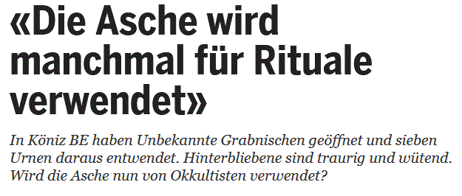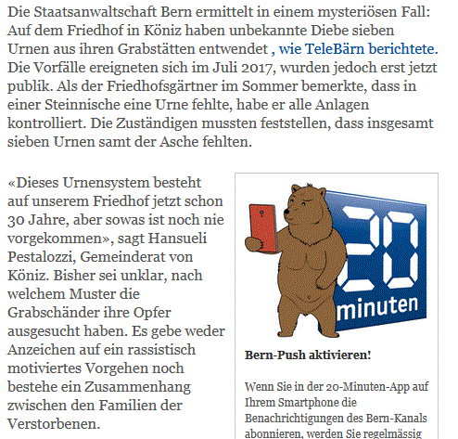

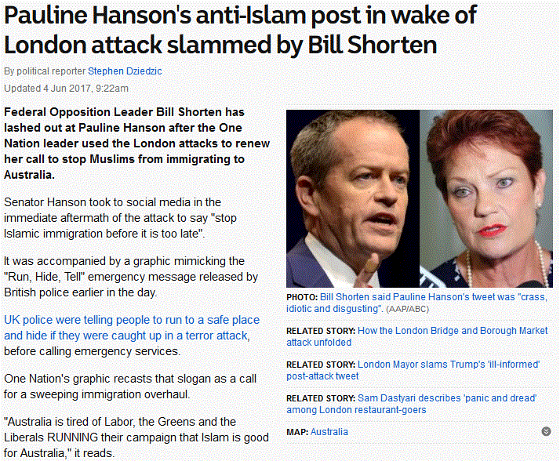

**Opinion/comment:**

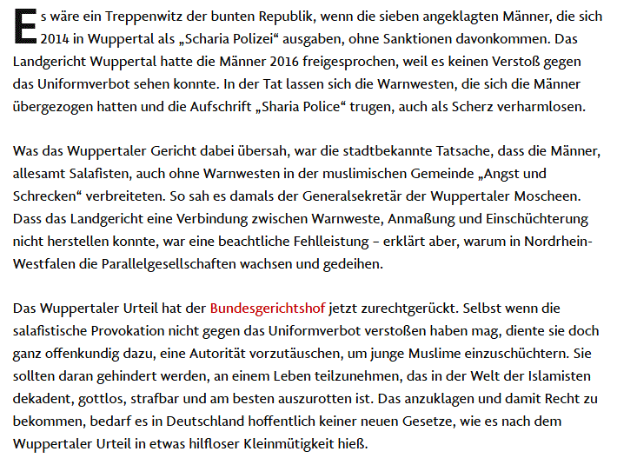

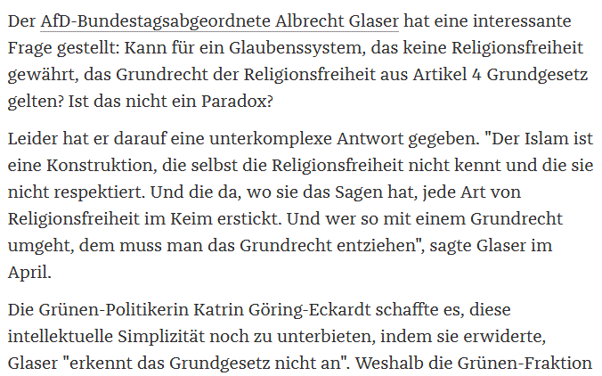

**Analysis:**

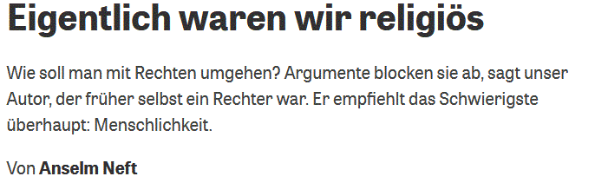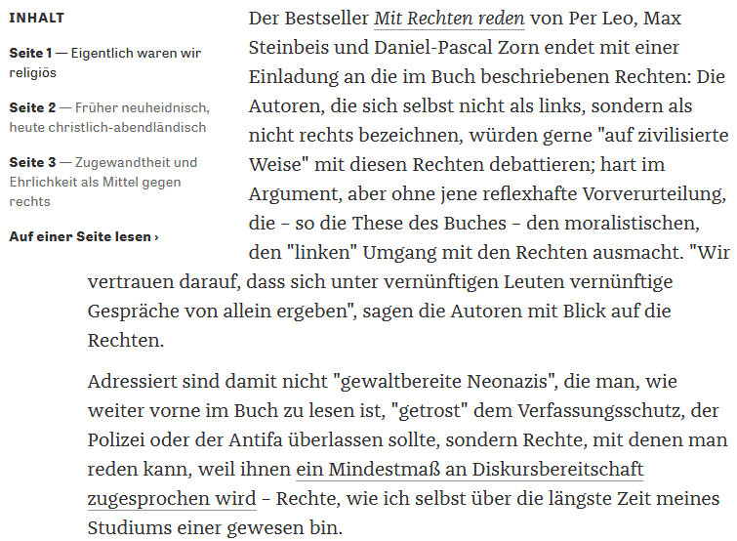

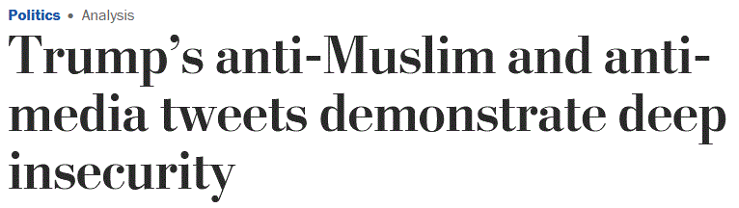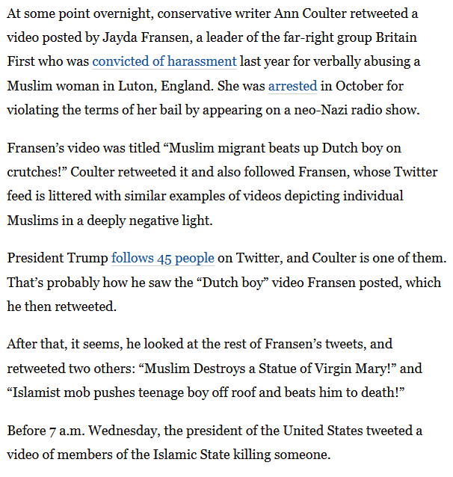

**Report:**

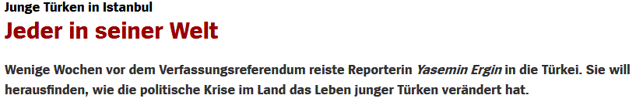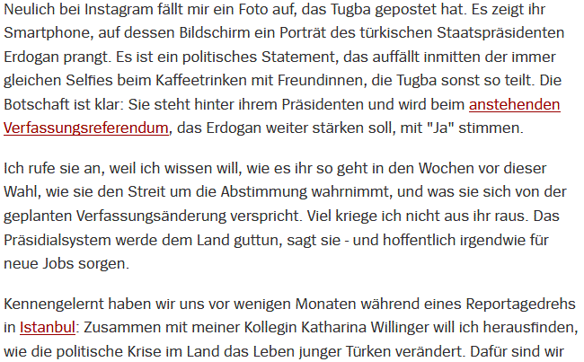

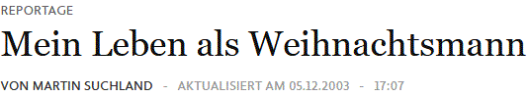

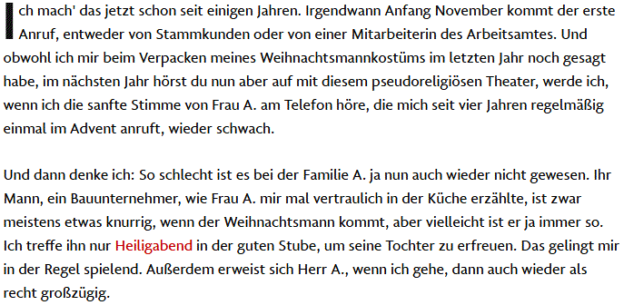

**Interview/discussion:**

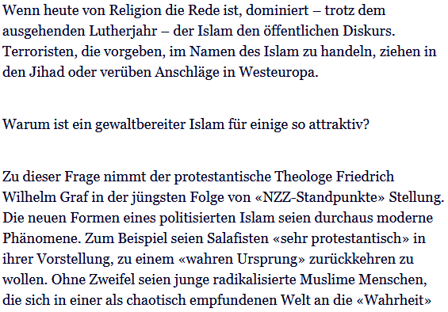

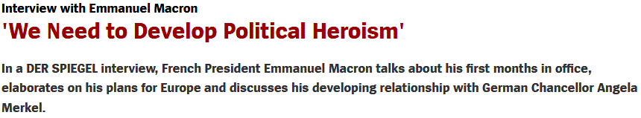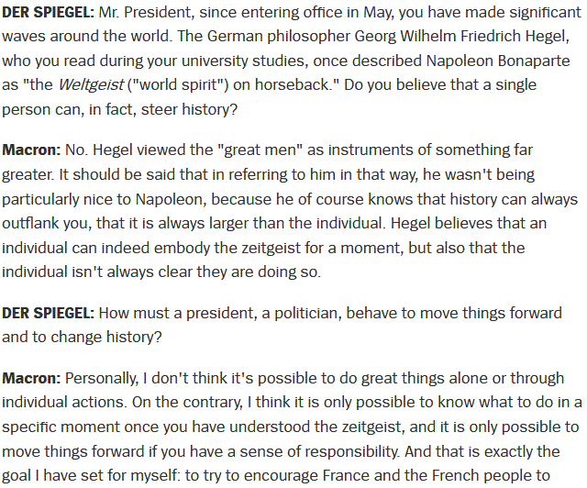

**Critique/review:**

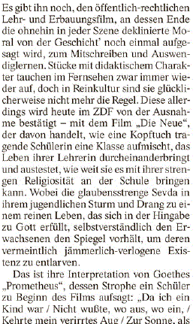

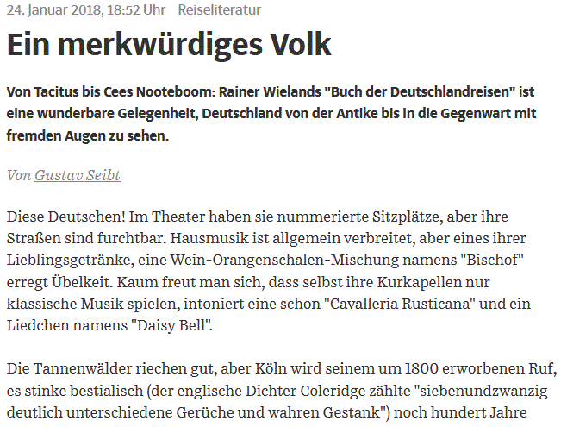

**Reprint:**

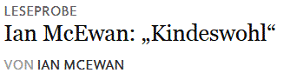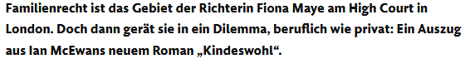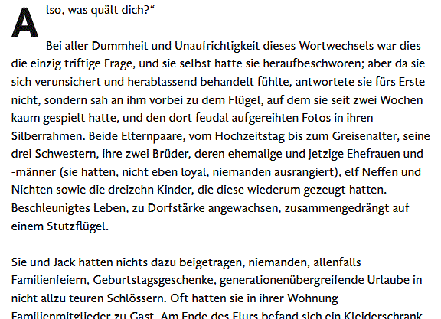



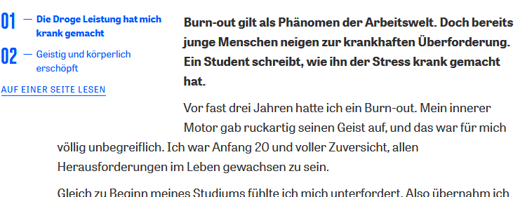

**Letter to the editor:**

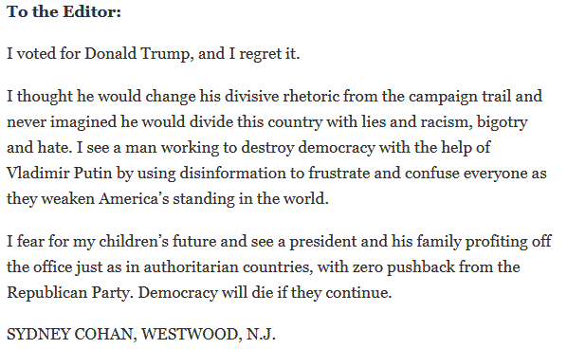

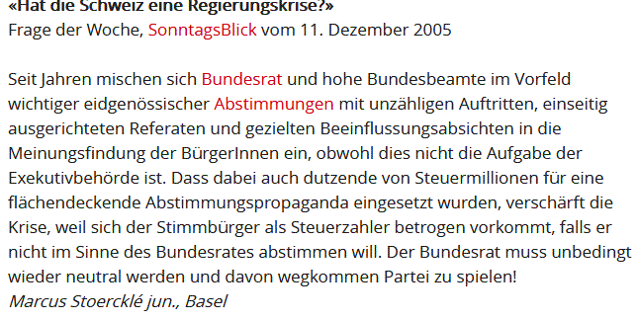

**Appendix 2: list of country codes**

|  |  |
| --- | --- |
| Country | Abbr |
| Afghanistan | AF |
| Åland Islands | AX |
| Albania | AL |
| Algeria | DZ |
| American Samoa | AS |
| Andorra | AD |
| Angola | AO |
| Anguilla | AI |
| Antarctica | AQ |
| Antigua and Barbuda | AG |
| Argentina | AR |
| Armenia | AM |
| Aruba | AW |
| Australia | AU |
| Austria | AT |
| Azerbaijan | AZ |
| Bahamas (the) | BS |
| Bahrain | BH |
| Bangladesh | BD |
| Barbados | BB |
| Belarus | BY |
| Belgium | BE |
| Belize | BZ |
| Benin | BJ |
| Bermuda | BM |
| Bhutan | BT |
| Bolivia (Plurinational State of) | BO |
| Bonaire, Sint Eustatius and Saba | BQ |
| Bosnia and Herzegovina | BA |
| Botswana | BW |
| Bouvet Island | BV |
| Brazil | BR |
| British Indian Ocean Territory (the) | IO |
| Brunei Darussalam | BN |
| Bulgaria | BG |
| Burkina Faso | BF |
| Burundi | BI |
| Cabo Verde | CV |
| Cambodia | KH |
| Cameroon | CM |
| Canada | CA |
| Cayman Islands (the) | KY |
| Central African Republic (the) | CF |
| Chad | TD |
| Chile | CL |
| China | CN |
| Christmas Island | CX |
| Cocos (Keeling) Islands (the) | CC |
| Colombia | CO |
| Comoros (the) | KM |
| Congo (the Democratic Republic of the) | CD |
| Congo (the) | CG |
| Cook Islands (the) | CK |
| Costa Rica | CR |
| Côte d'Ivoire | CI |
| Croatia | HR |
| Cuba | CU |
| Curaçao | CW |
| Cyprus | CY |
| Czech Republic (the) | CZ |
| Denmark | DK |
| Djibouti | DJ |
| Dominica | DM |
| Dominican Republic (the) | DO |
| Ecuador | EC |
| Egypt | EG |
| El Salvador | SV |
| Equatorial Guinea | GQ |
| Eritrea | ER |
| Estonia | EE |
| Ethiopia | ET |
| Falkland Islands (the) [Malvinas] | FK |
| Faroe Islands (the) | FO |
| Fiji | FJ |
| Finland | FI |
| France | FR |
| French Guiana | GF |
| French Polynesia | PF |
| French Southern Territories (the) | TF |
| Gabon | GA |
| Gambia (the) | GM |
| Georgia | GE |
| Germany | DE |
| Ghana | GH |
| Gibraltar | GI |
| Greece | GR |
| Greenland | GL |
| Grenada | GD |
| Guadeloupe | GP |
| Guam | GU |
| Guatemala | GT |
| Guernsey | GG |
| Guinea | GN |
| Guinea-Bissau | GW |
| Guyana | GY |
| Haiti | HT |
| Heard Island and McDonald Islands | HM |
| Holy See (the) | VA |
| Honduras | HN |
| Hong Kong | HK |
| Hungary | HU |
| Iceland | IS |
| India | IN |
| Indonesia | ID |
| Iran (Islamic Republic of) | IR |
| Iraq | IQ |
| Ireland | IE |
| Isle of Man | IM |
| Israel | IL |
| Italy | IT |
| Jamaica | JM |
| Japan | JP |
| Jersey | JE |
| Jordan | JO |
| Kazakhstan | KZ |
| Kenya | KE |
| Kiribati | KI |
| Korea (the Democratic People's Republic of) | KP |
| Korea (the Republic of) | KR |
| Kuwait | KW |
| Kyrgyzstan | KG |
| Lao People's Democratic Republic (the) | LA |
| Latvia | LV |
| Lebanon | LB |
| Lesotho | LS |
| Liberia | LR |
| Libya | LY |
| Liechtenstein | LI |
| Lithuania | LT |
| Luxembourg | LU |
| Macao | MO |
| Macedonia (the former Yugoslav Republic of) | MK |
| Madagascar | MG |
| Malawi | MW |
| Malaysia | MY |
| Maldives | MV |
| Mali | ML |
| Malta | MT |
| Marshall Islands (the) | MH |
| Martinique | MQ |
| Mauritania | MR |
| Mauritius | MU |
| Mayotte | YT |
| Mexico | MX |
| Micronesia (Federated States of) | FM |
| Moldova (the Republic of) | MD |
| Monaco | MC |
| Mongolia | MN |
| Montenegro | ME |
| Montserrat | MS |
| Morocco | MA |
| Mozambique | MZ |
| Myanmar | MM |
| Namibia | NA |
| Nauru | NR |
| Nepal | NP |
| Netherlands (the) | NL |
| New Caledonia | NC |
| New Zealand | NZ |
| Nicaragua | NI |
| Niger (the) | NE |
| Nigeria | NG |
| Niue | NU |
| Norfolk Island | NF |
| Northern Mariana Islands (the) | MP |
| Norway | NO |
| Oman | OM |
| Pakistan | PK |
| Palau | PW |
| Palestine, State of | PS |
| Panama | PA |
| Papua New Guinea | PG |
| Paraguay | PY |
| Peru | PE |
| Philippines (the) | PH |
| Pitcairn | PN |
| Poland | PL |
| Portugal | PT |
| Puerto Rico | PR |
| Qatar | QA |
| Réunion | RE |
| Romania | RO |
| Russian Federation (the) | RU |
| Rwanda | RW |
| Saint Barthélemy | BL |
| Saint Helena, Ascension and Tristan da Cunha | SH |
| Saint Kitts and Nevis | KN |
| Saint Lucia | LC |
| Saint Martin (French part) | MF |
| Saint Pierre and Miquelon | PM |
| Saint Vincent and the Grenadines | VC |
| Samoa | WS |
| San Marino | SM |
| Sao Tome and Principe | ST |
| Saudi Arabia | SA |
| Senegal | SN |
| Serbia | RS |
| Seychelles | SC |
| Sierra Leone | SL |
| Singapore | SG |
| Sint Maarten (Dutch part) | SX |
| Slovakia | SK |
| Slovenia | SI |
| Solomon Islands | SB |
| Somalia | SO |
| South Africa | ZA |
| South Georgia and the South Sandwich Islands | GS |
| South Sudan | SS |
| Spain | ES |
| Sri Lanka | LK |
| Sudan (the) | SD |
| Suriname | SR |
| Svalbard and Jan Mayen | SJ |
| Swaziland | SZ |
| Sweden | SE |
| Switzerland | CH |
| Syrian Arab Republic | SY |
| Taiwan (Province of China) | TW |
| Tajikistan | TJ |
| Tanzania, United Republic of | TZ |
| Thailand | TH |
| Timor-Leste | TL |
| Togo | TG |
| Tokelau | TK |
| Tonga | TO |
| Trinidad and Tobago | TT |
| Tunisia | TN |
| Turkey | TR |
| Turkmenistan | TM |
| Turks and Caicos Islands (the) | TC |
| Tuvalu | TV |
| Uganda | UG |
| Ukraine | UA |
| United Arab Emirates (the) | AE |
| United Kingdom of Great Britain and Northern Ireland (the) | GB |
| United States Minor Outlying Islands (the) | UM |
| United States of America (the) | US |
| Uruguay | UY |
| Uzbekistan | UZ |
| Vanuatu | VU |
| Vatican City | VA |
| Venezuela (Bolivarian Republic of) | VE |
| Viet Nam | VN |
| Virgin Islands (British) | VG |
| Virgin Islands (U.S.) | VI |
| Wallis and Futuna | WF |
| Western Sahara* | EH |
| Yemen | YE |
| Zambia | ZM |
| Zimbabwe | ZW |

**Appendix 3: forms of outrage (adapted from Berry & Sobieraj, 2014**

***Insulting language***This variable is intended to measure whether the author or speaker uses insulting words in reference to a person, group of people (e.g., immigrants, journalists, Democrats), branch of the government, political party, or other organization or their behaviors, planned behaviors, policies, or views. This variable should specifically capture insulting words (stupid, pompous, idiot), not all insults more generally speaking. For example, describing someone as “a child” is insulting, but does not use insulting words so should not be counted as insulting language.

For example, “asinine” in reference to a person or group’s behavior is “insulting language,” but if the person or group is called “asinine,” reserve this for the “name calling” variable.

Examples:

* “He needs to shut up.”
* “The whole idea was asinine.”
* “The policy was stupid, plain and simple.”

1. ***Name calling***This variable is intended to measure whether the author or speaker engages in name calling in reference to a person, group of people (e.g., immigrants, journalists, Democrats), branch of the government, political party or other organization. Affectionate, light-hearted teasing should be weeded out. Instead, look for name-calling that is used to make the subject look foolish/inept, hypocritical, deceitful, or dangerous.

Examples:

* “He’s asinine.”
* “You are a lunatic.”

1. ***Emotional display***

This variable is unlikely to appear in printed text (e.g., blog posts, webpages), but would most likely be communicated through “shouting” via the deliberate use of all caps, multiple exclamation points, enlarged text, etc. Emotional display is about the FORM of expression, see Emotional language for emotional content, although the two will often present concurrently and each should be noted.

Example:

* Use of all capital letters in a written document (for dramatic emphasis)

1. ***Emotional language***

This variable is intended to measure whether the author or speaker engages in verbal or written expressions of emotion in reference to a person, group of people (e.g., immigrants, journalists, Democrats), branch of the government, political party or other organization. Emotion words related to anger, fear, and sadness are the key indicators. Emotional language is about the literal content of what is said/written, rather than how it is communicated. Emotional display, on the other hand, is about the way something is said/written of expression.

Examples:

* “I’m furious!”
* “I’m infuriated!”
* “This is an outrage!”
* “This makes me sick!”

1. ***Verbal fighting/sparring***

This variable is intended to capture aggressive jousting between speakers. In interviews it may take the form of dismissive interruptions or rude exchanges between the interviewer and the interviewed characterized by a lack of civility.

Examples:

* Dismissive interruptions
* Talking over someone in an aggressive manner
* Saying things like “give me a break” or “come on” while someone else is speaking

1. ***Character assassination***

These are ad hominem attacks. This variable is intended to measure whether the author attempts to damage the reputation of a person, group of people (e.g., immigrants, journalists, Democrats), branch of the government, political party, or other organization by attacking their character. In politics, questioning the veracity of a statement is common, and should not be confused with character assassination, which is more extreme. Saying someone was not honest in a reply to a journalist is not character assassination, but saying that someone is a liar who cannot be trusted is character assassination.

Examples:

* “He is corrupt.”
* “McCain is a pure lying bastard! If he had a red tie on, he'd look you straight in the eye and insist it was blue.”

1. ***Misrepresentative exaggeration***This variable is intended to measure whether the author or speaker engages in very dramatic negative exaggeration in reference to the behaviors, planned behaviors, policies, or views of a person, group of people (e.g., immigrants, journalists, Democrats), branch of the government, political party, or other organization, such that it significantly misrepresents or obscures the truth.

Examples:

* “Obama is ‘Left of Lenin’.”
* “Democrats have designs on planting the seeds of socialism in the US.”
* “Obama backs a freedom of choice act to abolish every restriction on abortion in every state.”

1. ***Mockery*** This variable is intended to measure whether the author or speaker makes fun of the behaviors, planned behaviors, policies, or views of a person, group of people (e.g., immigrants, journalists, Democrats), branch of the government, political party or other organization to make the subject look bad or to rally others in criticism of the subject. Affectionate, light-hearted teasing should be weeded out. Instead, look for humor that is used to make the subject look foolish/inept, hypocritical, deceitful, or dangerous. It might also come in the form of a physical impersonation intended to make others laugh at the expense of the subject.

Examples:

* “Funny idea: that a politician is declared crazy when he talks about the state of the schools, the New Year's Eve in Cologne, or the traffic jam. The traffic jam, the great, misunderstood niche topic of our time that nobody else dares to talk about. Except Christian Lindner. Which is why he is tired. Very attractively tired.”
* “When Charlie Gibson asked about her foreign policy credentials, Sarah Palin said--with a straight face--she lives near Russia. Yesterday, the McCain campaign said--with a straight face--that by sitting next to foreigners for a few minutes while paparazzi took pictures, Palin was "boosting her foreign policy credentials" and giving herself "experience with foreign leaders…I think this new proximity approach to building a resume is brilliant! We should all do it; it saves so much time and effort. Why go to school and struggle with learning stuff and then have to spend years working your way up a career when you can simply plop yourself down next to something and get the same results? I could become a pediatric surgeon by having a latte in the Children's Hospital coffee shop. I could watch the Space Shuttle take off from that viewing spot across the water and become an astronaut.” (ridiculous/inept person)
* “If the subject matter weren't so serious and dire, this would be a comedy. This is a bunch of Senator Blowhards and Foghorns all giving their opening statements. We're looking at a Bunch of Colonel Sanders telling the chickens that they shouldn't have come into the coop. I mean these are the guys that screwed this up in many cases.” (ridiculous/hypocritical group)
* “Our illustrious leader reads from his teleprompter to tell us how our economy reached this point. It has nothing to do with policy over the last 7 years. It is because of "investors from abroad." He's so sweet. Just read or listen and make your own assumptions about these "justifications." Isn't our leader so sweet? I just want to pinch him on the cheeks and ask, "you do have Scotch nearby?" (note: also belittling)

1. ***Conflagration***  
   This variable is intended to capture attempts made to escalate non-scandals into scandals. In this variable, record speech that overstates or dramatizes the importance or implications of minor gaffes, oversights, or improprieties. By non-scandal we refer to an episode, event, or trend that a learned, dispassionate observer would not consider significant or scandalous.

Examples:

* The relationship between Ayers and Obama, which was discussed during the 2008 election campaign. Ayers is a pedagogue and the founder of a left-wing radical organization. Later, it came out that they had no close relationship with each other, but knew each other only fleetingly because they lived in the same neighbourhood.
* In 2015, Syrian refugee Anas Modamani took a selfie with German Chancellor Angela Merkel. Shortly thereafter, several photomontages are published showing Modamani as a terrorist. In the attacks in Brussels or in Berlin, these images were published on social networks again and again, although the man cannot be associated with any of these attacks.

1. ***Ideologically extremizing language***This variable is intended to capture extremist language used to critically describe a person, group of people (e.g., immigrants, journalists, Democrats), branch of the government, political party or other organization or their behaviors, planned behaviors, policies, or views. Usually the descriptive language will be used as an implicit slur rather than as a simple description.

Examples:

* Left-wing
* Right-wing
* Far right
* Far left
* Radical
* Extreme
* Reactionary

1. ***‚Slippery slope‘ arguments***

This variable is intended to capture fatalistic arguments, which suggest that some behavior, policy, or decision is a small step that will inevitably pave the way for much more extreme behaviors, policies, or decisions. Slippery slope arguments make dire forecasts about the future. When in doubt, do not use this code. True slippery slope arguments should be easy to identify.

Example:

* “…the far Left couldn't care less about gay "marriage.” They want to see the abolition of marriage as an institution and radical social change to redefine the human experience itself. This is precisely what we see in Scandinavian countries where this nonsense has played out to its logical extension: The rates of cohabitation are skyrocketing, and the institution of marriage is rapidly dying off. Girls and boys grow up in a culture and see no picture of marriage to emulate or aspire to. There is really no end to the aberrant forms of human sexuality that will come to the courthouse also demanding "marriage." And when marriage can mean anything, marriage means nothing.”

1. ***Belittling***This variable is intended to measure whether the author or speaker demeans a person, group of people (e.g., immigrants, journalists, Democrats), branch of the government, political party or other organization (or their behaviors, planned behaviors, policies, or views). Belittling generally attempts to deflate or undercut a person’s status. For example, the speaker/author may suggest that an adult is childlike/immature, suggest someone fairly accomplished is of low class status, or imply that a man is in some way feminine. This may be done in the context of mockery or exaggeration.

Example:

* Dave Letterman’s joke, “So John McCain calls up and says I’m not going to be there kids, because everything is going to hell, but the funny thing is that no one told his vice presidential candidate, Sarah Palin, and honest to God, right now she’s still circling the theater in a white minivan. She’s gonna pick him up later...”

1. ***Obscene language***This variable is intended to measure whether the author or speaker uses obscene language in reference to a person, group of people (e.g., immigrants, journalists, Democrats), branch of the government, political party or other organization (or their behaviors, planned behaviors, policies, or views). For the purposes of this study, obscenities include:

* **F-word derivatives**: Words based on, or incorporating, the F-word. Examples include fucker and motherfucker.
* **Scatological terms**: Words that have to do with feces, urine and defecation. Examples include "shit," "bullshit," "shithead," and piss.
* **Anatomical terms**: Words referring to parts of the human anatomy, mostly the private parts, and are considered crude. Examples include "ass," "asshole," "dick," "dickhead," and "tits."
* **Mild obscenities**: Words used in everyday language, but that may be offensive to some. Examples include "damn," "hell," as well as milder forms of anatomical terms like "boobs."
* **Derogatory terms**: Words or expressions that are used to denigrate and insult one's racial or ethnic background, gender or sexual orientation: Examples include the N-word, whore/ho/slut, various anti-Semitic terms, and anti-homosexual terms like faggot.

**Reference:**

Berry, J. M., & Sobieraj, S. (2014). *The outrage industry: Political opinion media and the new incivility*. *Studies in postwar American political development*. Oxford, UK: Oxford University Press.